CS Endeavors

Teacher: Mrs. Moses

This course primarily follows the A+ College Ready 6th Grade Computer Science Endeavors Curriculum.

Unit 1: Block Coding 1

Unit 2: Block Coding 2

Unit 3: Algorithms

Unit 4 (If time allows): The Internet of Things

*At this time, the plan is to integrate Drone competitions into the CS Endeavors class.*

**Coding Safety**

For this class we will use CSFirst. It is a Google Integration with Scratch. This means they will have access to the Scratch coding page, but not the whole platform. Students should obtain parent permission if they wish to access the full Scratch website. Please know that the full Scratch website is a public site. There are games that may not be age appropriate and anyone can view their work. They should not register using their real name as their username - that is also public and anyone can see it. Scratch encourages users to use a fake “coder” name as their username when registering.

**Course Description:**  The course covers a wide range of computer science topics such as problem solving, designing, debugging, deconstructing, code analysis, artificial intelligence, and the Internet of Things. The A+ curriculum is split into four units. Material will be supplements as needed for additional practice, topics, and skill development to prepare students for the next grade level. This course will meet the 6th grade standards for Digital Literacy and Computer Science.

**Prerequisites:** None

**Supply List:**

Please bring the following items with you to class each day.

* Pencils
* Color Pencils and/or Highlighters
* Glue Sticks
* *Charged* Chromebooks
* Loose-Leaf Paper
* HIS Planner
* headphones/earbuds
* Composition Notebook (for definitions and notes)
* Folder or small binder (to keep up with any papers you need to take to or from class to finish assignments)

**Instructional Delivery Plan:** This course will primarily utilize online learning platforms. Students are expected to adhere to the HCS Technology policies at all times. We will learn through a mixture of individual, partner, and group work.

**Homework:** There will be limited homework in this course. Majority of homework will be work started in class that was not completed.

**Students in this course will have Vocabulary Tests via Quizizz. These tests will be open for approx. 2 weeks each time. They will be given all terms and definitions and are allowed to use their coding notebooks (composition notebooks). Students will have 3 attempts and the highest score will be taken. Students may use time in class *after* they have finished other assignments or complete them outside of class during the open window. Vocabulary Quizizz will *NOT* be accepted late!**

**Primary Course Objectives**

Students will…

* explore basic coding concepts through block coding.
* create working code and games.
* demonstrate their knowledge and understanding in hands-on activities and challenges throughout the year.
* actively participate and engage with their fellow classmates to increase their understanding of course concepts.

**ALSDE Foundational/Recurring Standards**

1. Identify, demonstrate, and apply personal safe use of digital devices.
2. Recognize and demonstrate age-appropriate responsible use of digital devices and resources as outlined in school/district rules.
3. Assess the validity and identify the purpose of digital content.
4. Identify and employ appropriate troubleshooting techniques used to solve computing or connectivity issues.
5. Locate and curate information from digital sources to answer research questions.
6. Produce, review, and revise authentic artifacts that include multimedia using appropriate digital tools.

**CTSO (Career Tech Student Organization) Integration**

We will follow competition standards and hold classroom competitions based on TSA (Technical Student Association) Standards. Students in this class are also eligible to try out for the drone competition team.

**Embedded Numeracy**

Students will use math and numeracy skills to complete challenges throughout the year and a final course project. Students will use the coordinate plane as well as simple math equations utilizing addition and subtraction to complete coding challenges.

**Embedded Literacy**

Students will need to read and decode examples of code they are given. As students learn to recognize the coding blocks and learn the decoding process, they will learn how to compose code in different ways to complete their challenges and games!

**Embedded Science**

Students will not have many embedded science concepts during this course. In more advanced courses students will add in additional science concepts such as velocity.

**Anchor Project**

The coding assignments and challenges in this course will build upon themselves. By the end of the coding challenges, students will be able to complete the final coding challenge using all of the literacy and numeracy skills covered in the course.

**Industry Recognized Credentials**

Not applicable - Students will be given this opportunity in higher level courses at HHS.

**Attendance Matters!**

If students are out, they are expected to make up any missing assignments. This course builds on itself, so the quicker they make them up the better. We will learn new concepts regularly. Makeup work will be posted on Google Classroom as well as a recording of the class lecture for any new concepts taught. Please make sure you pay attention to the directions on the Google Classroom assignment. Sometimes the make-up directions are different from the in-class directions (to account for partner or group work).

**Self Advocacy**

I am ALWAYS open to parent questions; however, I encourage students to ask questions and try to find solutions on their own! Speaking up for yourself in a respectful way is a valuable skill!

**Grading Scale**

This course follows the Hartselle City Schools grading scale.

A - 90% - 100%

B - 80% - 89%

C - 70% - 79%

D - 60% - 69%

F - 59% and below

**Grading Percentages**

Course grades will have the following assigned weights:

Major Grades: Tests/Projects - 60%

Minor Grades: Class Activities/Mini-Projects - 30%

Homework: 10% (Because I do not assign typical homework, this will be their grade for uploading their evidence to their Student Led Conference Site each nine weeks. They will learn more about this in their history classes.)

**Grading Policies**

I do my best to grade everything within 3 days. I try to grade in class as students complete the assignment/task and provide immediate feedback whenever possible. Larger projects will take longer to provide more attention to detail and detailed feedback. I do my best to add comments and feedback in PowerSchool as well as the student’s Google Classroom.

**Contact Information**

Email is the best way to contact me. I am always more than happy to schedule a time to talk on the phone when students are not currently in my classroom, but email is the quickest way to get in touch with me for questions or to schedule a phone call or conference time.

Email: [cheyenne.moses@hartselletigers.org](mailto:cheyenne.moses@hartselletigers.org)

Remind group code (a QR code is at the end of the syllabus): he23cdb

**Google Classroom**

There should be a Google Classroom navigation video posted at the top of the “classwork” tab in Google Classroom for my course. Students will also receive an overview in class. I encourage all parents to watch the video with their students! I have tried to cover all of the features and it should be applicable in all classes that use Google Classroom - not just this one!

Google Classroom Class Codes (only join the class for your assigned class period):

3rd Period: bcvpj7x

7th Period: jmzt6mt

To join Google Classroom, sign in and click the “+” in the top right hand corner of the screen. A box will pop up for you to enter the class code.

**Parent Google Classroom Information**

Parents can get summaries from Google Classroom. Your student should be able to “invite” you. I can also add you on my side as well. If you would like to be added and didn’t complete the parent information form at Open House, please complete the form and indicate that you would like me to add you to Google Classroom so you can receive summaries. This will add you for all of the classes your student is enrolled in. This view will be different from the student view. In order to see everything your student sees, you will need to have your student log in to show you or have their information.

**Make-Up Work**

You have 1 calendar week from the day you are absent to submit make-up work.

* **Sooner is better** - many assignments will relate to the robots and the competitions. This means that a lot of the work will be documentation for your engineering notebooks. We want to keep them as organized as possible and add things in order.
* If I have “lectured” or demonstrated something new, I will record my computer screen and the lecture to post on Google Classroom along with the assignment.

Submit the missed assignment form at the top of “Classwork” in Google Classroom for all make-up work. You must do this for any paper or digital assignments!

Notable sections from the HCS Student handbook about make-up work:

* Students who are absent are required to make up work missed in each class. It is the student’s responsibility to obtain all make-up work from his/her teacher(s) immediately upon return to school.
* Long term assignments, such as research papers, special projects, etc. are still due on or before the due date even if the student is absent on the date the assignment is due.
* Students with unexcused absences will make up work for partial credit - grade will be calculated equal to 70% of the earned score.

For unexcused absences: If I have already graded the assignment and calculated it at 70% of the grade but an excuse was turned in and the PowerSchool absence was changed after the grade was posted, there will be a section of the missed assignment form to indicate this. There is not a time limit for students to submit the form for assignments in the current nine weeks for this purpose!

**Late Work**

* I will accept late work for up to two weeks OR the end of the unit - whichever is first.
* Late work will only receive HALF of the earned credit.
* The late work window is from the initial due date
  + If you are absent, you will still have your 1 week period for make-up work, but you will only have 1 additional week for it to be considered late work.

You MUST fill out the missed assignment form at the top of “Classwork” in Google Classroom. This is for both digital and paper assignments. I will not grade them without the form!

**Missed Assignment Form**

* The missed assignment form is required to be submitted for all late work or makeup work.
* I will go through this with students in class and we will practice submitting it.
* It can be found at the top of the “Classwork” tab on Google Classroom.
* This form will close the Monday before each nine weeks ends and no late work will be accepted at that time. I will remind students before this happens!

**Tiger Way Expectations**

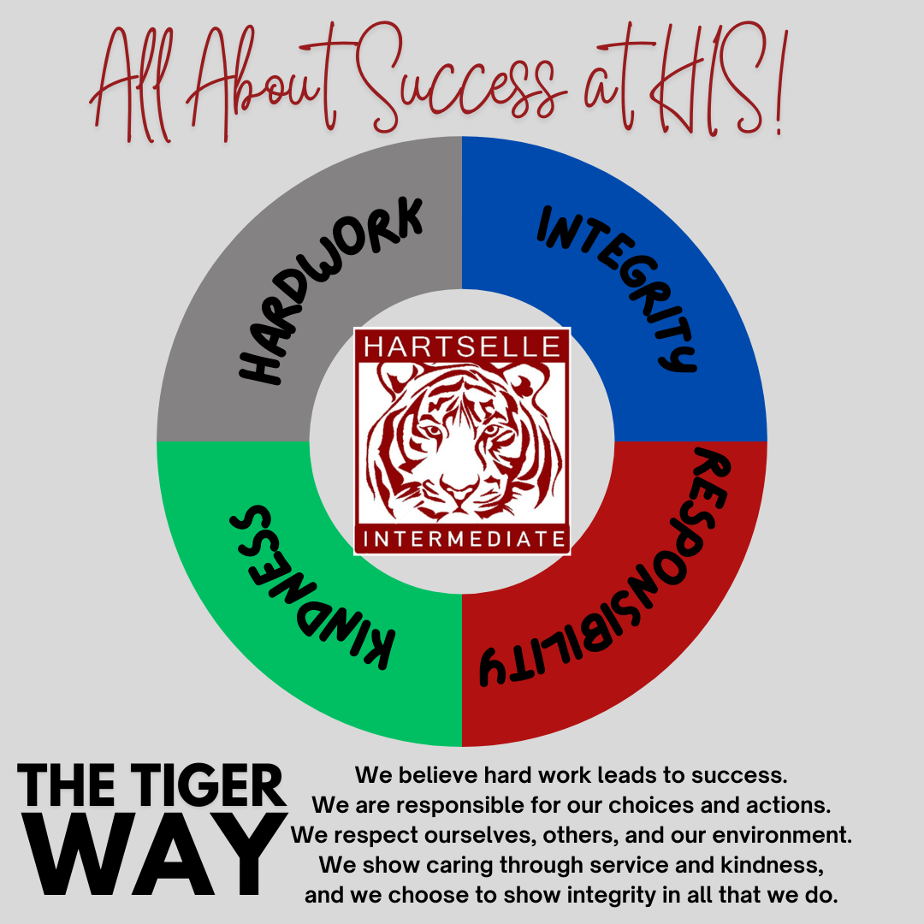

**Class Rules**

Students are expected to…

* Respect each other
* Respect Mrs. Moses (or any other adult in the room)
* Respect the classroom equipment
* Show up with their required supplies each day
* Be ready to learn
* Complete work in a timely manner and ask questions when needed
* Listen attentively to instructions
* Follow directions

No gum, food, drinks, or candy will be allowed!

**Class Procedures/Do’s and Don’ts/Specific Expectations**

**Entering the classroom**

Students are expected to…

* Find their seat and begin the warm up on the board
* Store backpacks under desks (if this becomes a problem we will designate a section of the room to store backpacks during class time).

Do’s

* Get supplies out
* Sharpen pencils
* Turn in work
* Check the board for warm ups
* Put away all food, drink, and/or candy
* Spit out gum

Don’ts

* Ask questions in the doorway
* Surround me in the doorway while I’m greeting students
* Continue to socialize instead of beginning the warm-up

*All warm-ups will be posted on Google Classroom with the assignment for the day.

**Exiting the classroom**

Students are expected to…

* Remain seated until dismissed
* Make sure their area is clean and all supplies are put away

Do’s

* Make sure your area is clean
* Throw all trash away
* Put all class supplies away in the correct area
* Push your chair in
* Walk - Don’t run

Don’ts

* Leave trash out
* Push others
* Leave your chair out
* Leave supplies out

**Independent Work**

Independent work should be completed *individually.*

Do’s

* Work on the current assignment
* Raise your hand for help

Don’ts

* Walk around the classroom
* Talk to/distract other students from their work
* Yell across the room for help

**Partner/Group Work**

This class contains a lot of partner or group work. Please make sure you are working together responsibly. All partners/group members should be actively contributing to the group in order to receive credit. If you do not contribute to the group, you will not receive credit.

Do’s

* Work on the current assignment
* Raise your hand for help from the teacher
* Respect the opinions of ALL group members
* Actively participate and contribute to your group

Don’ts

* Walk around the classroom (this does not mean students can’t go get robot parts or needed supplies - they shouldn’t be roaming)
* Talk to/distract other groups from their projects
* Yell across the room for help
* Exclude group members
* Refuse to help your group

**Turning in Work**

* Check the assignment details to make sure you are submitting your assignment correctly
  + We will go over how to submit each type of assignment and practice together as a class when introducing a new online platform or assignment type.
* Coding assignments - these will vary based on the assignment and coding platform used.
* Google Classroom - Assignments completed on Google Classroom digitally will be submitted there. Make sure you click the “submit” or “turn in” button!
* Worksheets - Worksheets will be submitted in one of the following ways
  + Glued into the coding notebook (computer science)
  + Uploaded to the digital engineering notebook (robotics)
  + Turned in to the turn in tray
    - Make sure it has your name
    - Make sure it is in the tray for your class!

**Pencil Sharpener**

* The pencil sharpener is currently located by the door.
* You are allowed to use it AS NEEDED. This means you do not have to ask me to use it; however, it should be used at appropriate times.
* If you have a personal handheld sharpener that catches the shavings, you may use it at your desk at any time!
* I recommend having a back-up pencil if you do not have a personal sharpener.

Good times to use the pencil sharpener:

* During independent work time
* During partner or group work time
* BEFORE class starts

Bad times to use the pencil sharpener:

* When the teacher is talking
* During class instruction/in the middle of a lesson
* When another student is asking a question during instruction time

**Leaving the Room During Class Time**

Students should not miss instruction time unless absolutely necessary! I will not go back and cover what is missed if a student leaves during instruction. They will need to watch the recording later or get notes to see what is missed. It isn’t fair to everyone else in the room if we have to cover the same thing multiple times because people are leaving.

Students should only leave if there is an emergency and they are not able to wait. They will be required to sign in and out and document the times and reason they are leaving.

* Bathroom - you should go to the bathroom between classes.
* Water - You should get water between classes. There is a fountain right outside of my room!
* Nurse - You should only go to the nurse if you are bleeding or sick! The nurse is here to help - she isn’t an excuse to roam the halls and miss class.

**Snack Time/2nd Breakfast Expectations**

* All classroom equipment should be put away before snack time.
* Make sure you clean up all of your trash and wipe any crumbs/food/spills off of the tables.
* If you spill something, you are responsible for cleaning it up!

**Lunch Time Expectations**

* If you have lunch with me, we will go as a class.
* You will clean up 2-3 minutes before the bell rings to end lunch.
* We will have designated table washers each day.
* All tables must be cleared and trash thrown away.
* The tables and floors are not to be left dirty.
* We will return to the room as a class.

**Technology and Chromebooks**

Students are not allowed to have phones or use smart watches as phones throughout the day. They should be stored in their locker.

Students should not access any website they have not been given permission to access by the teacher. This includes websites for other classes. Students will be given a list of taks to choose from if they finish an assignment early.

**Consequences**

1. Student Conference/Students sign documentation log
2. Student will complete the Tiger Way reflection form.
   1. Parent will be contacted.
   2. It will be documented in the classroom log
3. Lunch Detention
   1. Parent will be contacted.
   2. It will be documented in the classroom log
4. Office Referral

